Decision Log – 2 - Updated

0. Context – Why does this question exist?
Project / assignment this belongs to:
StackEval Benchmark – Professional Research Project
Why this matters right now:
Before executing the StackEval experiment, it is necessary to determine which LLM models will be evaluated.
Following feedback on the initial model selection and further research into current LLM ecosystems, the selection criteria evolved. Instead of choosing the most widely used models, the focus shifted toward selecting the latest publicly available models to better reflect the current state-of-the-art.
Additionally, in Decision Log 3, the decision to use API-based querying influenced this choice, as only API-accessible models can be reliably used in an automated benchmark.

1. Research Question
Which LLM models should be selected to represent different categories of the current LLM ecosystem when benchmarking real programming questions using the StackEval approach?

2. Current Learning Outcome (LO) Stage
☑ Analyzing
☑ Advising
☐ Designing
☐ Realizing
☐ Managing

3. What Makes a Good Decision?
Criteria for Success:
• The experiment must include at least four models representing different LLM categories.
• The selected models must represent the latest available state-of-the-art systems, ensuring the benchmark reflects current industry capabilities.
• The models must be API-accessible, enabling consistent and automated querying (aligned with Decision Log 3).
• The number of models must remain manageable to ensure feasible analysis within the project scope.

4. Decision
The benchmark will evaluate four LLM models, each representing a different segment of the current LLM ecosystem, based on the latest available versions.
Selected Models
Frontier proprietary model
GPT-5.4 (OpenAI)
Frontier competitor
Claude Sonnet 4.6 (Anthropic)
Open-source model
Llama 4 (Meta AI)
Budget / lightweight model
GPT-5.4-mini (OpenAI)

5. Reasoning Behind the Decision
Method Used
Structured Socratic reasoning and Literature study methodology combined with product analysis (reviewing official websites and API platforms of OpenAI, Anthropic, and Meta) was used to evaluate available LLM options.
Additionally, insights from Decision Log 3 were incorporated, where API-based querying was selected as the benchmark execution method.
To validate feasibility, I directly explored the official websites and API platforms of each provider to confirm that the selected models are accessible via API and suitable for automated benchmarking.

Observations
Initially, model selection was based on widely used and commonly referenced models. However, after feedback and further research, this approach was reconsidered.
Key observations:
• The LLM ecosystem evolves rapidly, making “widely used” models potentially outdated.
• Benchmarking only commonly used models may not reflect current capabilities.
• Modern AI providers continuously release improved versions (e.g., GPT-5.4, Claude 4.6, Llama 4).
• By reviewing official websites and API platforms, it was confirmed that these latest models are actively supported and accessible.
• Benchmark platforms show that these models are already being evaluated and compared in real-world scenarios.
• The decision to use API-based querying requires selecting models that are:
- officially available via provider platforms
- API-accessible
- stable enough for experimentation

Evidence & Artifacts
OpenAI. (2026). ChatGPT Socratic dialogue discussion [Large language model]. https://chatgpt.com/share/69b7f668-b368-8002-90b6-d4634e666ecd
Screenshot of the reasoning process included in portfolio evidence
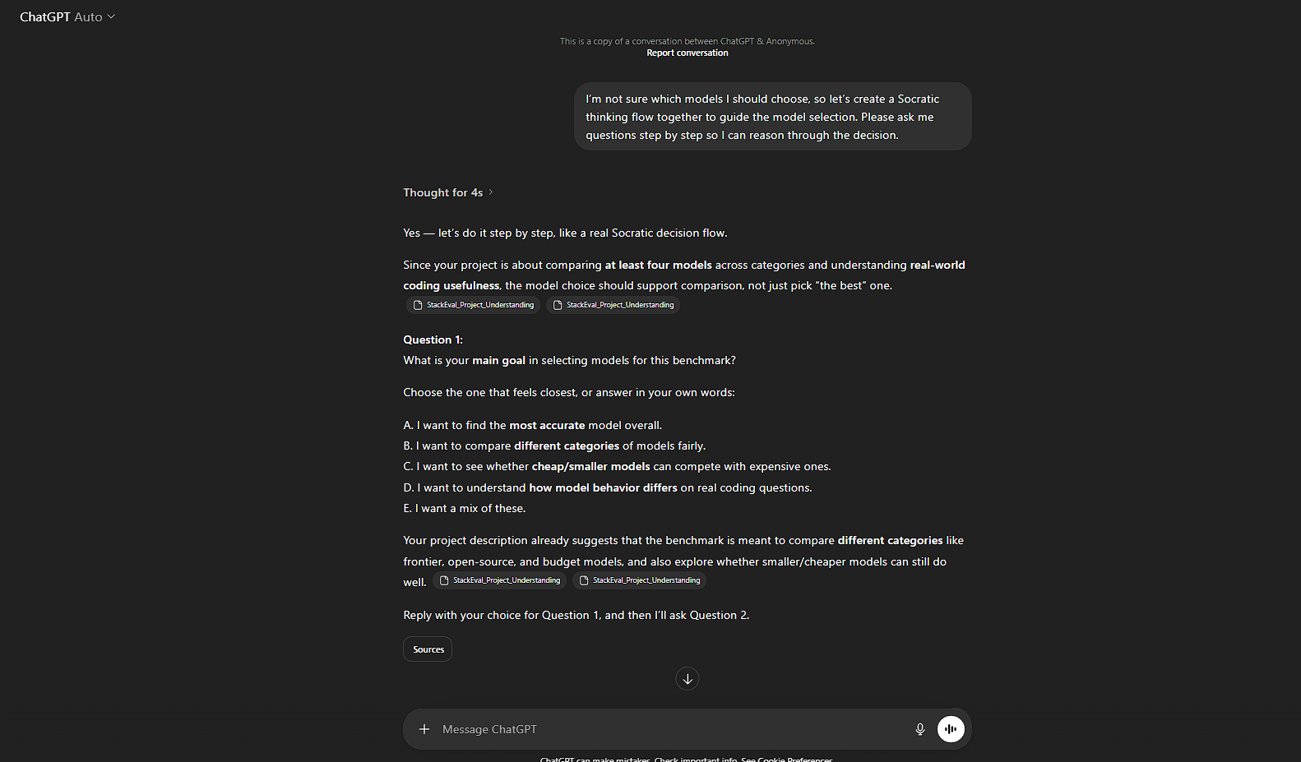

OpenAI. (2026). Models API and platform overview. https://developers.openai.com/api/docs/models
Anthropic. (2026). Claude API platform. https://platform.claude.com/docs/en/home
OpenRouter. (2026). Meta Llama models via API platform. https://openrouter.ai/meta-llama
ProLLM. (2026). LLM leaderboard and benchmark comparisons. https://www.prollm.ai/leaderboard
Decision Log 3 confirming API-based querying as the chosen method, ensuring consistency and reproducibility
The Model Selection Research document supports and confirms the findings discussed in this research

Interpretation:
The model selection strategy improved significantly compared to the initial version.
Previously: Models were selected based on popularity and initial exploratory analysis and LLMs’ categories
Now: Models are selected based on:
- latest models
- API accessibility
- different ecosystem categories
This allows the benchmark to:
• Evaluate the current state-of-the-art
• Compare different providers (OpenAI, Anthropic, Meta)
• Analyze differences between:
- frontier vs budget models
- proprietary vs open-source systems

Why This Decision Is Better Than the Previous Version
The updated approach improves the experiment because:
✔ Reflects latest technological advancements instead of older baselines
✔ Aligns with API-based execution, ensuring feasibility
✔ Ensures models are verified through official websites and API platforms and accessible in practice
✔ Improves relevance of results for real-world applications
✔ Strengthens academic justification by linking decisions across logs

Final Decision
Four models representing different categories of the LLM ecosystem will be evaluated, with a focus on the latest available models that are accessible via API.

6. Evaluation of the Decision
How Well This Meets the Criteria
Criterion 1 – Representation of model categories
✅ Four models representing distinct categories were selected
Criterion 2 – State-of-the-art relevance
✅ Models represent the latest available versions
Criterion 3 – API accessibility
✅ All models are compatible with API-based querying either directly or via external API providers (e.g., OpenRouter)
Criterion 4 – Experiment manageability
✅ The number of models remains manageable

Assumptions
• The selected models are stable enough for benchmarking
• API access is available and affordable
• Llama 4 can be accessed via external platforms

Reflection
Initially, I assumed that selecting widely used models would be the best approach. However, after receiving feedback and conducting further research, I realized that this does not necessarily reflect the current state of LLM development.
Additionally, the decision to use API-based querying (Decision Log 3) influenced model selection, as it requires models to be programmatically accessible and consistent.
This led to a shift in thinking from:
“Which models are most commonly used?”
to:
“Which models best represent the current state-of-the-art and can be reliably benchmarked?”

7. What This Unlocks
Next LO Stage: Realizing
The experiment can now be implemented using API-based querying and automated scripts.

What I Can Now Do
• Connect to model APIs
• Send identical prompts across all models
• Collect and store responses systematically
• Compare model outputs on real programming questions

How I Will Know This Worked
All selected models will return responses to the same Stack Overflow questions via API, allowing a consistent and fair comparison of answer quality.

